Starting on Friday (July 26th), I left CDPHE and picked up sampling supplies at the lab. I then went home (147 Keystone Trail, Broomfield, 80020) via coworker Mindi May’s home (2542 Lafayette St, Denver, 80205) to pick up additional supplies stored there from earlier in the week. Saturday I had to go to McGuckins and Home Depot in Boulder, CO to pick up the angle aluminum and concrete pavers to construct the final racks for the NDS study.

Monday morning I picked up coworker Mindi May at her home (2542 Lafayette St, Denver, 80205) on the way out of town to Walden. We then sampled the stations listed in the table below Monday-Friday and returned to Denver on Saturday. This trip totaled 1262.4 miles.

|  |  |  |  |
| --- | --- | --- | --- |
| **Stream Name** | **Description** | **Latitude** | **Longitude** |
| Michigan River | @ Walden (above WWTF) | 40.741061 | -106.279738 |
| Michigan River | Below WWTF | 40.745373 | -106.29673 |
| Michigan River | @ Hwy 14 d/s of S. Fork | 40.55371 | -106.0434 |
| Bear River | d/s Yamcolo Reservoir | 40.06146 | -107.01203 |
| Yampa River | d/s Yampa @ CR21 | 40.18281 | -106.91539 |
| Yampa River | u/s Stagecoach Res. @ CR16 | 40.26907 | -106.88223 |
| Yampa River | @ CR22 | 40.39897 | -106. 833871 |
| Yampa River | d/s WWTF @ CR33A Rd | 40.491508 | -106.94801 |
| Gore Creek | d/s WWTF | 39.640194 | -106.399546 |
| Gore Creek | @ Forest Rd in Vail | 39.641344 | -106.392865 |
| Gore Creek | @ East Vail Exit (#180) | 39.643253 | -106.308322 |
| Roaring Fork River | @ Difficult Campground (2nd R) | 39.141743 | -106.775604 |
| Roaring Fork River | u/s WWTF @ walking bridge | 39.21797 | -106.854638 |
| Roaring Fork River | d/s WWTF | 39.225594 | -106.861133 |
| San Miguel River | d/s WWTF | 37.948209 | -107.877067 |
| San Miguel River | @ Society Turn (u/s WWTF) | 37.948736 | -107.868937 |
| San Miguel River | u/s Marshall Creek | 37.930197 | -107.781663 |

Denver – home – Boulder – home – Mindi’s – Walden – Steamboat – Yamcolo Reservoir

394 miles

Yamcolo – Steamboat – Vail – Aspen – Telluride – Denver

891 miles

Even though I tried to map this trip as close as possible, the mileage indicated by Google Maps is actually farther (1285 miles) than the odometer trip that I recorded during the actual field trip (1262.4 miles).

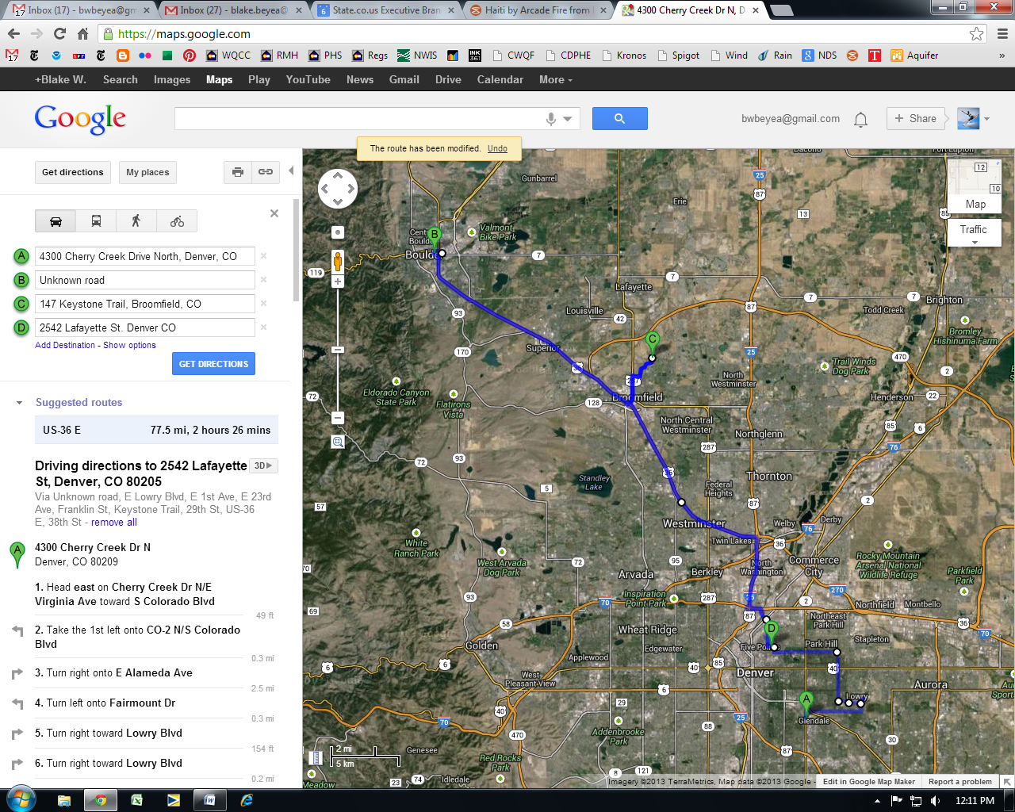

Figure . Driving required Friday-Monday morning.

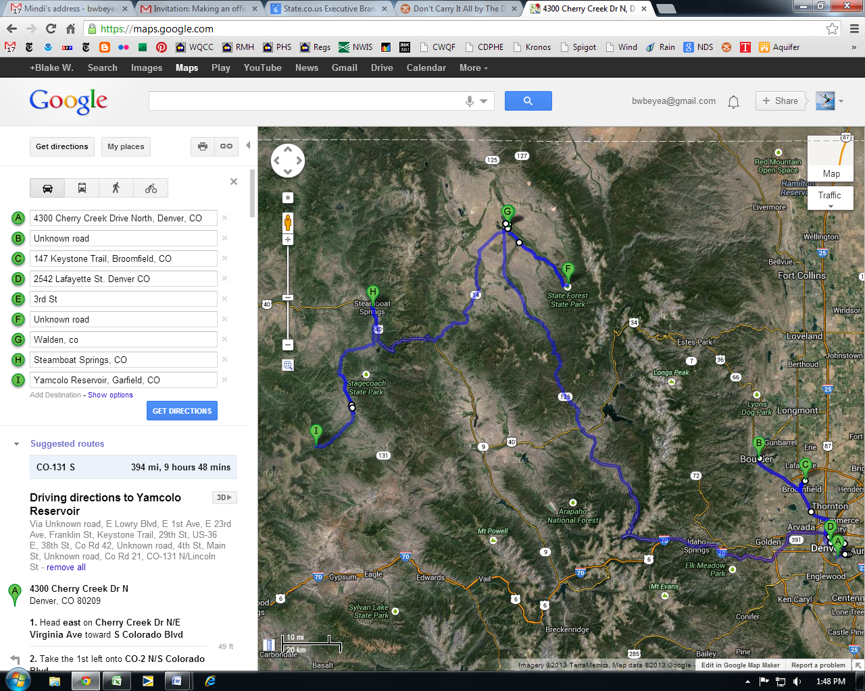

Figure . Driving required Friday-midday Tuesday.

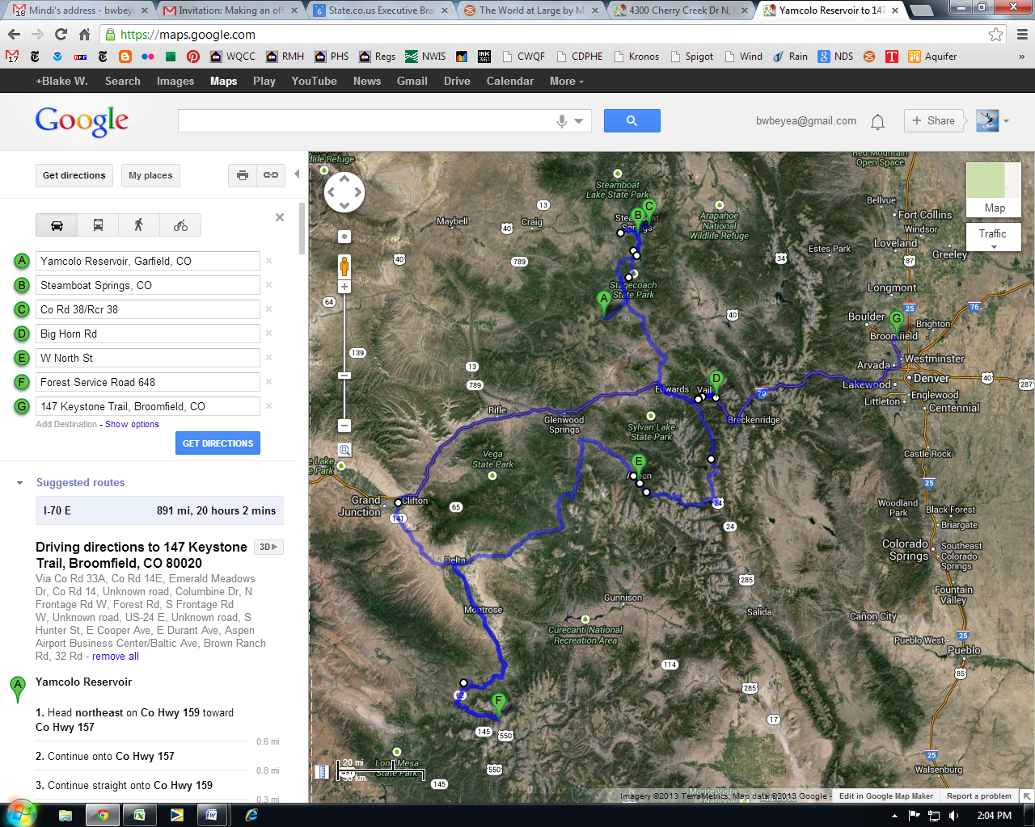

Figure . Driving required Tuesday midday - Saturday.

1. **CO-131 S**

|  |  |
| --- | --- |
| **Driving directions to Yamcolo Reservoir** | [**3Dhttps://maps.gstatic.com/intl/en_us/mapfiles/transparent.png**](javascript:void(0)) |

Via Unknown road, E Lowry Blvd, E 1st Ave, E 23rd Ave, Franklin St, Keystone Trail, 29th St, US-36 E, 38th St, Co Rd 42, Unknown road, 4th St, Main St, Unknown road, Co Rd 21, CO-131 N/Lincoln St - [remove all](javascript:void(0))

|  |  |  |  |
| --- | --- | --- | --- |
| https://maps.gstatic.com/mapfiles/markers2/marker_greenA.png | **4300 Cherry Creek Dr N**  Denver, CO 80209 | https://maps.gstatic.com/mapfiles/transparent.png | |
|  | **1.** Head **east** on **Cherry Creek Dr N/E Virginia Ave** toward **S Colorado Blvd** | | https://maps.gstatic.com/mapfiles/transparent.png |
|  |  | | 49 ft |
|  | **2.** Take the 1st left onto **CO-2 N/S Colorado Blvd** | | https://maps.gstatic.com/mapfiles/transparent.png |
|  |  | | 0.3 mi |
|  | **3.** Turn right onto **E Alameda Ave** | | https://maps.gstatic.com/mapfiles/transparent.png |
|  |  | | 2.5 mi |
|  | **4.** Turn left onto **Fairmount Dr** | | https://maps.gstatic.com/mapfiles/transparent.png |
|  |  | | 0.3 mi |
|  | **5.** Turn right toward **Lowry Blvd** | | https://maps.gstatic.com/mapfiles/transparent.png |
|  |  | | 154 ft |
|  | **6.** Turn right toward **Lowry Blvd** | | https://maps.gstatic.com/mapfiles/transparent.png |
|  |  | | 0.2 mi |
|  | **7.** Turn right onto **Lowry Blvd** | | https://maps.gstatic.com/mapfiles/transparent.png |
|  |  | | 0.2 mi |
|  | **8.** At the traffic circle, take the **3rd** exit and stay on **Lowry Blvd** | | https://maps.gstatic.com/mapfiles/transparent.png |
|  |  | | 0.4 mi |
|  | **9.** At the traffic circle, continue straight onto**E Lowry Blvd** | | https://maps.gstatic.com/mapfiles/transparent.png |
|  |  | | 0.4 mi |
|  | **10.** Turn right onto **Quebec St** | | https://maps.gstatic.com/mapfiles/transparent.png |
|  |  | | 456 ft |
|  | **11.** Take the 1st left onto **E 1st Ave** | | https://maps.gstatic.com/mapfiles/transparent.png |
|  |  | | 0.5 mi |
|  | **12.** Turn right onto **Monaco Pkwy** | | https://maps.gstatic.com/mapfiles/transparent.png |
|  |  | | 2.3 mi |
|  | **13.** Turn left onto **E 23rd Ave** | | https://maps.gstatic.com/mapfiles/transparent.png |
|  |  | | 3.0 mi |
|  | **14.** Turn right onto **Franklin St** | | https://maps.gstatic.com/mapfiles/transparent.png |
|  |  | | 0.3 mi |
|  | **15.** Turn left onto **E 26th Ave** | | https://maps.gstatic.com/mapfiles/transparent.png |
|  |  | | 0.3 mi |
|  | **16.** Turn right onto **Downing St** | | https://maps.gstatic.com/mapfiles/transparent.png |
|  |  | | 0.8 mi |
|  | **17.** Turn right onto **E 35th Ave** | | https://maps.gstatic.com/mapfiles/transparent.png |
|  |  | | 98 ft |
|  | **18.** Continue straight to stay on **E 35th Ave** | | https://maps.gstatic.com/mapfiles/transparent.png |
|  |  | | 240 ft |
|  | **19.** Turn left onto **Marion St** | | https://maps.gstatic.com/mapfiles/transparent.png |
|  |  | | 0.3 mi |
|  | **20.** Turn left onto **38th St** | | https://maps.gstatic.com/mapfiles/transparent.png |
|  |  | | 0.5 mi |
|  | **21.** Continue onto **Washington St** | | https://maps.gstatic.com/mapfiles/transparent.png |
|  |  | | 0.4 mi |
|  | **22.** Turn left onto the **I-25 W/I-70 W** ramp | | https://maps.gstatic.com/mapfiles/transparent.png |
|  |  | | 0.3 mi |
|  | **23.** Keep right at the fork, follow signs for **I-25 N/Thornton/Ft Collins** and merge onto **I-25 N** | | https://maps.gstatic.com/mapfiles/transparent.png |
|  |  | | 3.0 mi |
|  | **24.** Take exit **217A** on the left to merge onto**US-36 W** toward **Boulder** | | https://maps.gstatic.com/mapfiles/transparent.png |
|  |  | | 9.3 mi |
|  | **25.** Take the **Colorado 121** exit toward **U.S. 287/Broomfield/Lafayette** | | https://maps.gstatic.com/mapfiles/transparent.png |
|  |  | | 0.2 mi |
|  | **26.** Turn right onto **CO-121 N** | | https://maps.gstatic.com/mapfiles/transparent.png |
|  |  | | 0.3 mi |
|  | **27.** Continue onto **U.S. 287 N** | | https://maps.gstatic.com/mapfiles/transparent.png |
|  |  | | 0.9 mi |
|  | **28.** Turn right onto **Miramonte Blvd** | | https://maps.gstatic.com/mapfiles/transparent.png |
|  |  | | 0.4 mi |
|  | **29.** Take the 2nd left onto **Kohl St** | | https://maps.gstatic.com/mapfiles/transparent.png |
|  |  | | 0.9 mi |
|  | **30.** Continue onto **W 136th Ave** | | https://maps.gstatic.com/mapfiles/transparent.png |
|  |  | | 0.1 mi |
|  | **31.** Turn left onto **Outlook Trail** | | https://maps.gstatic.com/mapfiles/transparent.png |
|  |  | | 0.2 mi |
|  | **32.** Turn left onto **Breckenridge Trail** | | https://maps.gstatic.com/mapfiles/transparent.png |
|  |  | | 374 ft |
|  | **33.** Take the 1st left onto **Keystone Trail** | | https://maps.gstatic.com/mapfiles/transparent.png |
|  |  | | 141 ft |
|  | **34.** Make a U-turn | | https://maps.gstatic.com/mapfiles/transparent.png |
|  |  | | 141 ft |
|  | **35.** Turn right onto **Breckenridge Trail** | | https://maps.gstatic.com/mapfiles/transparent.png |
|  |  | | 374 ft |
|  | **36.** Turn right onto **Outlook Trail** | | https://maps.gstatic.com/mapfiles/transparent.png |
|  |  | | 0.2 mi |
|  | **37.** Turn right onto **W 136th Ave** | | https://maps.gstatic.com/mapfiles/transparent.png |
|  |  | | 0.1 mi |
|  | **38.** Continue onto **Kohl St** | | https://maps.gstatic.com/mapfiles/transparent.png |
|  |  | | 0.9 mi |
|  | **39.** Turn right onto **Miramonte Blvd** | | https://maps.gstatic.com/mapfiles/transparent.png |
|  |  | | 0.4 mi |
|  | **40.** Turn left onto **U.S. 287 S** | | https://maps.gstatic.com/mapfiles/transparent.png |
|  |  | | 0.9 mi |
|  | **41.** Continue onto **CO-121 S** | | https://maps.gstatic.com/mapfiles/transparent.png |
|  |  | | 0.3 mi |
|  | **42.** Take the ramp onto **US-36 W** | | https://maps.gstatic.com/mapfiles/transparent.png |
|  |  | | 11.6 mi |
|  | **43.** Turn left onto **Arapahoe Ave** | | https://maps.gstatic.com/mapfiles/transparent.png |
|  |  | | 0.2 mi |
|  | **44.** Turn right | | https://maps.gstatic.com/mapfiles/transparent.png |
|  |  | | 394 ft |
|  | **45.** Turn right | | https://maps.gstatic.com/mapfiles/transparent.png |
|  |  | | 200 ft |

43.4 mi – about 1 hour 26 mins

|  |  |  |  |
| --- | --- | --- | --- |
| https://maps.gstatic.com/mapfiles/markers2/marker_greenB.png | **Unknown road** | https://maps.gstatic.com/mapfiles/transparent.png | |
|  | **46.** Head **north** | | https://maps.gstatic.com/mapfiles/transparent.png |
|  |  | | 187 ft |
|  | **47.** Turn right toward **Canyon Blvd** | | https://maps.gstatic.com/mapfiles/transparent.png |
|  |  | | 223 ft |
|  | **48.** Turn left toward **Canyon Blvd** | | https://maps.gstatic.com/mapfiles/transparent.png |
|  |  | | 318 ft |
|  | **49.** Turn right onto **Canyon Blvd** | | https://maps.gstatic.com/mapfiles/transparent.png |
|  |  | | 0.2 mi |
|  | **50.** Turn right onto **28th St** (signs for **CO-7 S/US-36**) | | https://maps.gstatic.com/mapfiles/transparent.png |
|  |  | | 0.2 mi |
|  | **51.** Take the 1st left onto **Arapahoe Ave** | | https://maps.gstatic.com/mapfiles/transparent.png |
|  |  | | 0.1 mi |
|  | **52.** Turn left onto **29th St** | | https://maps.gstatic.com/mapfiles/transparent.png |
|  |  | | 0.2 mi |
|  | **53.** Turn left onto **Canyon Blvd** | | https://maps.gstatic.com/mapfiles/transparent.png |
|  |  | | 0.1 mi |
|  | **54.** Turn left onto **US-36 E/28th St**  Continue to follow US-36 E | | https://maps.gstatic.com/mapfiles/transparent.png |
|  |  | | 11.4 mi |
|  | **55.** Take the **CO-121** exit toward **US-287/Broomfield/Arvada** | | https://maps.gstatic.com/mapfiles/transparent.png |
|  |  | | 0.3 mi |
|  | **56.** Turn left onto **CO-121 N/Interlocken Loop**  Continue to follow CO-121 N | | https://maps.gstatic.com/mapfiles/transparent.png |
|  |  | | 0.5 mi |
|  | **57.** Continue onto **U.S. 287 N** | | https://maps.gstatic.com/mapfiles/transparent.png |
|  |  | | 0.9 mi |
|  | **58.** Turn right onto **Miramonte Blvd** | | https://maps.gstatic.com/mapfiles/transparent.png |
|  |  | | 0.4 mi |
|  | **59.** Take the 2nd left onto **Kohl St** | | https://maps.gstatic.com/mapfiles/transparent.png |
|  |  | | 0.9 mi |
|  | **60.** Continue onto **W 136th Ave** | | https://maps.gstatic.com/mapfiles/transparent.png |
|  |  | | 0.1 mi |
|  | **61.** Turn left onto **Outlook Trail** | | https://maps.gstatic.com/mapfiles/transparent.png |
|  |  | | 0.2 mi |
|  | **62.** Turn left onto **Breckenridge Trail** | | https://maps.gstatic.com/mapfiles/transparent.png |
|  |  | | 374 ft |
|  | **63.** Take the 1st left onto **Keystone Trail**  Destination will be on the right | | https://maps.gstatic.com/mapfiles/transparent.png |
|  |  | | 141 ft |

15.8 mi – about 28 mins

|  |  |  |  |
| --- | --- | --- | --- |
| https://maps.gstatic.com/mapfiles/markers2/marker_greenC.png | **147 Keystone Trail**  Broomfield, CO 80020 | https://maps.gstatic.com/mapfiles/transparent.png | |
|  | **64.** Head **east** on **Keystone Trail** toward**Breckenridge Trail** | | https://maps.gstatic.com/mapfiles/transparent.png |
|  |  | | 141 ft |
|  | **65.** Turn right onto **Breckenridge Trail** | | https://maps.gstatic.com/mapfiles/transparent.png |
|  |  | | 374 ft |
|  | **66.** Turn right onto **Outlook Trail** | | https://maps.gstatic.com/mapfiles/transparent.png |
|  |  | | 0.2 mi |
|  | **67.** Turn right onto **W 136th Ave** | | https://maps.gstatic.com/mapfiles/transparent.png |
|  |  | | 0.1 mi |
|  | **68.** Continue onto **Kohl St** | | https://maps.gstatic.com/mapfiles/transparent.png |
|  |  | | 0.9 mi |
|  | **69.** Turn right onto **Miramonte Blvd** | | https://maps.gstatic.com/mapfiles/transparent.png |
|  |  | | 0.4 mi |
|  | **70.** Turn left onto **U.S. 287 S** | | https://maps.gstatic.com/mapfiles/transparent.png |
|  |  | | 0.9 mi |
|  | **71.** Continue onto **CO-121 S** | | https://maps.gstatic.com/mapfiles/transparent.png |
|  |  | | 0.5 mi |
|  | **72.** Turn left to merge onto **US-36 E** | | https://maps.gstatic.com/mapfiles/transparent.png |
|  |  | | 9.0 mi |
|  | **73.** Take the exit onto **I-25 S** toward **Denver** | | https://maps.gstatic.com/mapfiles/transparent.png |
|  |  | | 2.9 mi |
|  | **74.** Take exit **214A** for **I-70 E** toward **Limon** | | https://maps.gstatic.com/mapfiles/transparent.png |
|  |  | | 1.1 mi |
|  | **75.** Follow signs for **Washington St** | | https://maps.gstatic.com/mapfiles/transparent.png |
|  |  | | 0.2 mi |
|  | **76.** Turn right onto **Washington St** | | https://maps.gstatic.com/mapfiles/transparent.png |
|  |  | | 0.3 mi |
|  | **77.** Continue onto **38th St** | | https://maps.gstatic.com/mapfiles/transparent.png |
|  |  | | 0.4 mi |
|  | **78.** Turn right onto **Walnut St** | | https://maps.gstatic.com/mapfiles/transparent.png |
|  |  | | 0.1 mi |
|  | **79.** Turn left onto **Downing St** | | https://maps.gstatic.com/mapfiles/transparent.png |
|  |  | | 1.0 mi |
|  | **80.** Turn left onto **E 26th Ave** | | https://maps.gstatic.com/mapfiles/transparent.png |
|  |  | | 0.1 mi |
|  | **81.** Take the 2nd right onto **Lafayette St**  Destination will be on the left | | https://maps.gstatic.com/mapfiles/transparent.png |
|  |  | | 161 ft |

18.3 mi – about 33 mins

|  |  |  |  |
| --- | --- | --- | --- |
| https://maps.gstatic.com/mapfiles/markers2/marker_greenD.png | **2542 Lafayette St**  Denver, CO 80205 | https://maps.gstatic.com/mapfiles/transparent.png | |
|  | **82.** Head **south** on **Lafayette St** toward **E 25th Ave** | | https://maps.gstatic.com/mapfiles/transparent.png |
|  |  | | 299 ft |
|  | **83.** Take the 1st right onto **E 25th Ave** | | https://maps.gstatic.com/mapfiles/transparent.png |
|  |  | | 0.4 mi |
|  | **84.** Continue onto **Glenarm Pl** | | https://maps.gstatic.com/mapfiles/transparent.png |
|  |  | | 0.3 mi |
|  | **85.** Turn right onto **Park Ave W** | | https://maps.gstatic.com/mapfiles/transparent.png |
|  |  | | 1.4 mi |
|  | **86.** Merge onto **I-70 W** via the ramp to **Grand Jct** | | https://maps.gstatic.com/mapfiles/transparent.png |
|  |  | | 42.6 mi |
|  | **87.** Take exit **232** toward **U.S. 40 E/Empire/Granby** | | https://maps.gstatic.com/mapfiles/transparent.png |
|  |  | | 0.3 mi |
|  | **88.** Merge onto **US-40 W** | | https://maps.gstatic.com/mapfiles/transparent.png |
|  |  | | 48.7 mi |
|  | **89.** Turn right onto **CO-125 N** | | https://maps.gstatic.com/mapfiles/transparent.png |
|  |  | | 53.2 mi |
|  | **90.** Turn left onto **State Route 125 N/Main St** | | https://maps.gstatic.com/mapfiles/transparent.png |
|  |  | | 0.5 mi |
|  | **91.** Turn right onto **3rd St** | | https://maps.gstatic.com/mapfiles/transparent.png |
|  |  | | 0.1 mi |

147 mi – about 3 hours 2 mins

|  |  |  |  |
| --- | --- | --- | --- |
| https://maps.gstatic.com/mapfiles/markers2/marker_greenE.png | **3rd St** | https://maps.gstatic.com/mapfiles/transparent.png | |
|  | **92.** Head **west** on **3rd St** toward **Mc Kinley St** | | https://maps.gstatic.com/mapfiles/transparent.png |
|  |  | | 0.1 mi |
|  | **93.** Take the 1st right onto **CO-125 N/Main St**  Continue to follow CO-125 N | | https://maps.gstatic.com/mapfiles/transparent.png |
|  |  | | 0.7 mi |
|  | **94.** Take the 2nd right onto **Co Rd 42** | | https://maps.gstatic.com/mapfiles/transparent.png |
|  |  | | 0.7 mi |
|  | **95.** Make a U-turn | | https://maps.gstatic.com/mapfiles/transparent.png |
|  |  | | 0.5 mi |
|  | **96.** Slight right onto **Co Rd 42** | | https://maps.gstatic.com/mapfiles/transparent.png |
|  |  | | 0.2 mi |
|  | **97.** Turn left onto **CO-125 S** | | https://maps.gstatic.com/mapfiles/transparent.png |
|  |  | | 0.4 mi |
|  | **98.** Take the 1st right onto **1st St** | | https://maps.gstatic.com/mapfiles/transparent.png |
|  |  | | 0.5 mi |
|  | **99.** Turn right toward **CO-125 S** | |  |
|  |  | | 1.6 mi |
|  | **100.** Turn right toward **CO-125 S** | |  |
|  |  | | 0.3 mi |
|  | **101.** Turn right onto **CO-125 S** | | https://maps.gstatic.com/mapfiles/transparent.png |
|  |  | | 2.1 mi |
|  | **102.** Turn left onto **4th St** | | https://maps.gstatic.com/mapfiles/transparent.png |
|  |  | | 0.2 mi |
|  | **103.** Take the 3rd right onto **Harrison St** | | https://maps.gstatic.com/mapfiles/transparent.png |
|  |  | | 0.1 mi |
|  | **104.** Take the 1st right onto **5th St** | | https://maps.gstatic.com/mapfiles/transparent.png |
|  |  | | 0.2 mi |
|  | **105.** Take the 3rd right onto **Main St** | | https://maps.gstatic.com/mapfiles/transparent.png |
|  |  | | 0.1 mi |
|  | **106.** Take the 1st right onto **4th St** | | https://maps.gstatic.com/mapfiles/transparent.png |
|  |  | | 338 ft |
|  | **107.** Take the 1st right onto **Mc Kinley St** | | https://maps.gstatic.com/mapfiles/transparent.png |
|  |  | | 0.1 mi |
|  | **108.** Take the 1st left onto **5th St** | | https://maps.gstatic.com/mapfiles/transparent.png |
|  |  | | 0.2 mi |
|  | **109.** Take the 3rd right onto **Washington St** | | https://maps.gstatic.com/mapfiles/transparent.png |
|  |  | | 0.2 mi |
|  | **110.** Continue straight onto **CO-14 E** | | https://maps.gstatic.com/mapfiles/transparent.png |
|  |  | | 3.5 mi |
|  | **111.** Turn right toward **Co Rd 31** | | https://maps.gstatic.com/mapfiles/transparent.png |
|  |  | | 0.2 mi |
|  | **112.** Continue straight onto **Co Rd 31** | |  |
|  |  | | 0.3 mi |
|  | **113.** Turn right toward **Co Rd 31** | |  |
|  |  | | 0.2 mi |
|  | **114.** Make a U-turn | |  |
|  |  | | 0.2 mi |
|  | **115.** Turn left onto **Co Rd 31** | |  |
|  |  | | 0.5 mi |
|  | **116.** Turn right onto **CO-14 E** | | https://maps.gstatic.com/mapfiles/transparent.png |
|  |  | | 15.2 mi |
|  | **117.** Turn left onto **Co Rd 41** | | https://maps.gstatic.com/mapfiles/transparent.png |
|  |  | | 0.2 mi |

28.7 mi – about 53 mins

|  |  |  |  |
| --- | --- | --- | --- |
| https://maps.gstatic.com/mapfiles/markers2/marker_greenF.png | **Unknown road** |  | |
|  | **118.** Head **west** toward **Co Rd 41** | |  |
|  |  | | 0.2 mi |
|  | **119.** Turn right onto **CO-14 W** | | https://maps.gstatic.com/mapfiles/transparent.png |
|  |  | | 18.7 mi |
|  | **120.** Continue onto **Washington St** | | https://maps.gstatic.com/mapfiles/transparent.png |
|  |  | | 0.2 mi |
|  | **121.** Turn left onto **5th St** | | https://maps.gstatic.com/mapfiles/transparent.png |
|  |  | | 0.3 mi |
|  | **122.** Turn right onto **Le Fever St** | | https://maps.gstatic.com/mapfiles/transparent.png |
|  |  | | 0.2 mi |
|  | **123.** Take the 2nd left onto **North St** | | https://maps.gstatic.com/mapfiles/transparent.png |
|  |  | | 92 ft |

19.7 mi – about 23 mins

|  |  |  |  |
| --- | --- | --- | --- |
| https://maps.gstatic.com/mapfiles/markers2/marker_greenG.png | **Walden, CO** | https://maps.gstatic.com/mapfiles/transparent.png | |
|  | **124.** Head **east** on **North St** toward **Le Fever St** | | https://maps.gstatic.com/mapfiles/transparent.png |
|  |  | | 92 ft |
|  | **125.** Turn right onto **Le Fever St** | | https://maps.gstatic.com/mapfiles/transparent.png |
|  |  | | 0.2 mi |
|  | **126.** Take the 2nd left onto **5th St** | | https://maps.gstatic.com/mapfiles/transparent.png |
|  |  | | 338 ft |
|  | **127.** Take the 1st right onto **Main St** | | https://maps.gstatic.com/mapfiles/transparent.png |
|  |  | | 0.2 mi |
|  | **128.** Turn right onto **CO-125 S/CO-14 W/Main St** (signs for **Granby/Steamboat Springs/Denver**)  Continue to follow CO-125 S/CO-14 W | | https://maps.gstatic.com/mapfiles/transparent.png |
|  |  | | 1.2 mi |
|  | **129.** Turn right onto **CO-14 W/State Route 14 W** (signs for **Steamboat Springs/Kremmling**) | | https://maps.gstatic.com/mapfiles/transparent.png |
|  |  | | 32.8 mi |
|  | **130.** Turn right onto **US-40 W** | | https://maps.gstatic.com/mapfiles/transparent.png |
|  |  | | 24.7 mi |
|  | **131.** Turn right onto **6th St** | | https://maps.gstatic.com/mapfiles/transparent.png |
|  |  | | 164 ft |

59.1 mi – about 1 hour 5 mins

|  |  |  |  |
| --- | --- | --- | --- |
| https://maps.gstatic.com/mapfiles/markers2/marker_greenH.png | **Steamboat Springs, CO** | https://maps.gstatic.com/mapfiles/transparent.png | |
|  | **132.** Head **southwest** on **6th St** toward**Lincoln Ave** | | https://maps.gstatic.com/mapfiles/transparent.png |
|  |  | | 164 ft |
|  | **133.** Take the 1st left onto **US-40 E/Lincoln Ave**  Continue to follow US-40 E | | https://maps.gstatic.com/mapfiles/transparent.png |
|  |  | | 4.1 mi |
|  | **134.** Turn right onto **CO-131 S** | | https://maps.gstatic.com/mapfiles/transparent.png |
|  |  | | 24.1 mi |
|  | **135.** Turn right onto **Co Rd 21** | | https://maps.gstatic.com/mapfiles/transparent.png |
|  |  | | 1.8 mi |
|  | **136.** Continue onto **Co Rd 17/Rcr 17**  Continue to follow Co Rd 17 | | https://maps.gstatic.com/mapfiles/transparent.png |
|  |  | | 0.8 mi |
|  | **137.** Turn left onto **CO-131 N/Lincoln St**  Continue to follow CO-131 N | | https://maps.gstatic.com/mapfiles/transparent.png |
|  |  | | 9.1 mi |
|  | **138.** Turn left onto **Sharp Ave** | | https://maps.gstatic.com/mapfiles/transparent.png |
|  |  | | 171 ft |
|  | **139.** Take the 1st right toward **Bell Ave** | |  |
|  |  | | 459 ft |
|  | **140.** Turn right onto **Bell Ave** | |  |
|  |  | | 164 ft |
|  | **141.** Turn right onto **CO-131 S/W Main St**  Continue to follow CO-131 S | | https://maps.gstatic.com/mapfiles/transparent.png |
|  |  | | 9.2 mi |
|  | **142.** Slight right onto **Main St** | | https://maps.gstatic.com/mapfiles/transparent.png |
|  |  | | 0.5 mi |
|  | **143.** Turn right onto **S Moffat Ave** | | https://maps.gstatic.com/mapfiles/transparent.png |
|  |  | | 0.2 mi |
|  | **144.** Continue onto **Co Rd 7** | |  |
|  |  | | 2.0 mi |
|  | **145.** Slight right to stay on **Co Rd 7** | |  |
|  |  | | 2.0 mi |
|  | **146.** Continue onto **Rcr7** | |  |
|  |  | | 1.8 mi |
|  | **147.** Continue onto **US Frst Service Rd 900** | |  |
|  |  | | 4.4 mi |
|  | **148.** Continue onto **Co Hwy 159** | |  |
|  |  | | 0.3 mi |
|  | **149.** Continue onto **Co Hwy 158** | |  |
|  |  | | 367 ft |
|  | **150.** Continue onto **Co Hwy 159** | |  |
|  |  | | 0.7 mi |
|  | **151.** Slight left onto **Co Hwy 157** | |  |
|  |  | | 0.4 mi |
|  | **152.** Continue onto **Co Hwy 159** | |  |
|  |  | | 0.6 mi |

62.1 mi – about 1 hour 57 mins

|  |  |
| --- | --- |
| https://maps.gstatic.com/mapfiles/markers2/marker_greenI.png | **Yamcolo Reservoir** |

1. **I-70 E**

|  |  |
| --- | --- |
| **Driving directions to 147 Keystone Trail, Broomfield, CO 80020** | [**3Dhttps://maps.gstatic.com/intl/en_us/mapfiles/transparent.png**](javascript:void(0)) |

Via Co Rd 33A, Co Rd 14E, Emerald Meadows Dr, Co Rd 14, Unknown road, Columbine Dr, N Frontage Rd W, Forest Rd, S Frontage Rd W, Unknown road, US-24 E, Unknown road, S Hunter St, E Cooper Ave, E Durant Ave, Aspen Airport Business Center/Baltic Ave, Brown Ranch Rd, 32 Rd - [remove all](javascript:void(0))

|  |  |  |  |
| --- | --- | --- | --- |
| https://maps.gstatic.com/mapfiles/markers2/marker_greenA.png | **Yamcolo Reservoir** |  | |
|  | **1.** Head **northeast** on **Co Hwy 159** toward**Co Hwy 157** | |  |
|  |  | | 0.6 mi |
|  | **2.** Continue onto **Co Hwy 157** | |  |
|  |  | | 0.8 mi |
|  | **3.** Continue straight onto **Co Hwy 159** | |  |
|  |  | | 0.3 mi |
|  | **4.** Continue straight onto **Co Hwy 158** | |  |
|  |  | | 367 ft |
|  | **5.** Continue onto **Co Hwy 159** | |  |
|  |  | | 0.3 mi |
|  | **6.** Continue onto **US Frst Service Rd 900** | |  |
|  |  | | 4.4 mi |
|  | **7.** Continue onto **Rcr7** | |  |
|  |  | | 1.8 mi |
|  | **8.** Continue onto **Co Rd 7** | |  |
|  |  | | 3.9 mi |
|  | **9.** Continue onto **Moffat Ave** | |  |
|  |  | | 0.2 mi |
|  | **10.** Turn left onto **Main St** | | https://maps.gstatic.com/mapfiles/transparent.png |
|  |  | | 0.5 mi |
|  | **11.** Continue onto **CO-131 N/Lincoln St**  Continue to follow CO-131 N | | https://maps.gstatic.com/mapfiles/transparent.png |
|  |  | | 25.9 mi |
|  | **12.** Turn left onto **US-40 W** | | https://maps.gstatic.com/mapfiles/transparent.png |
|  |  | | 4.1 mi |
|  | **13.** Turn right onto **6th St**  Destination will be on the right | | https://maps.gstatic.com/mapfiles/transparent.png |
|  |  | | 164 ft |

43.0 mi – about 1 hour 28 mins

|  |  |  |  |
| --- | --- | --- | --- |
| https://maps.gstatic.com/mapfiles/markers2/marker_greenB.png | **Steamboat Springs, CO** | https://maps.gstatic.com/mapfiles/transparent.png | |
|  | **14.** Head **southwest** on **6th St** toward**Lincoln Ave** | | https://maps.gstatic.com/mapfiles/transparent.png |
|  |  | | 164 ft |
|  | **15.** Take the 1st right onto **US-40 W/Lincoln Ave**  Continue to follow US-40 W | | https://maps.gstatic.com/mapfiles/transparent.png |
|  |  | | 7.2 mi |
|  | **16.** Turn left onto **Co Rd 33A** | | https://maps.gstatic.com/mapfiles/transparent.png |
|  |  | | 1.0 mi |
|  | **17.** Make a U-turn | |  |
|  |  | | 0.2 mi |
|  | **18.** Continue straight onto **Co Rd 33A** | |  |
|  |  | | 0.8 mi |
|  | **19.** Turn right onto **US-40 E** | | https://maps.gstatic.com/mapfiles/transparent.png |
|  |  | | 7.2 mi |
|  | **20.** Turn left onto **7th St** | | https://maps.gstatic.com/mapfiles/transparent.png |
|  |  | | 0.4 mi |
|  | **21.** Turn left onto **Laurel St** | | https://maps.gstatic.com/mapfiles/transparent.png |
|  |  | | 335 ft |
|  | **22.** Turn right onto **Park Ave** | | https://maps.gstatic.com/mapfiles/transparent.png |
|  |  | | 0.3 mi |
|  | **23.** Turn left onto **N Park Rd** | | https://maps.gstatic.com/mapfiles/transparent.png |
|  |  | | 407 ft |
|  | **24.** Take the 1st right onto **Strawberry Park Rd** | | https://maps.gstatic.com/mapfiles/transparent.png |
|  |  | | 0.8 mi |
|  | **25.** Turn left onto **Co Rd 36/Rcr 36** | | https://maps.gstatic.com/mapfiles/transparent.png |
|  |  | | 0.8 mi |
|  | **26.** Take the 1st right onto **Co Rd 38/Rcr 38**  Continue to follow Co Rd 38 | |  |
|  |  | | 6.1 mi |

24.9 mi – about 55 mins

|  |  |  |  |
| --- | --- | --- | --- |
| https://maps.gstatic.com/mapfiles/markers2/marker_greenC.png | **Co Rd 38/Rcr 38** |  | |
|  | **27.** Head **north** on **Co Rd 38/Rcr 38**  Continue to follow Co Rd 38 | |  |
|  |  | | 6.1 mi |
|  | **28.** Turn left onto **Co Rd 36/Rcr 36** | |  |
|  |  | | 0.8 mi |
|  | **29.** Continue onto **Amethyst Dr** | | https://maps.gstatic.com/mapfiles/transparent.png |
|  |  | | 1.7 mi |
|  | **30.** Turn right onto **Fish Creek Falls Rd** | | https://maps.gstatic.com/mapfiles/transparent.png |
|  |  | | 0.3 mi |
|  | **31.** Take the 1st left onto **3rd St** | | https://maps.gstatic.com/mapfiles/transparent.png |
|  |  | | 387 ft |
|  | **32.** Take the 1st left onto **US-40 E/Lincoln Ave**  Continue to follow US-40 E | | https://maps.gstatic.com/mapfiles/transparent.png |
|  |  | | 3.9 mi |
|  | **33.** Turn right onto **CO-131 S** | | https://maps.gstatic.com/mapfiles/transparent.png |
|  |  | | 5.3 mi |
|  | **34.** Turn right onto **Co Rd 14E** | | https://maps.gstatic.com/mapfiles/transparent.png |
|  |  | | 1.8 mi |
|  | **35.** Slight right onto **Rcr35** | |  |
|  |  | | 0.5 mi |
|  | **36.** Continue onto **Co Rd 14** | |  |
|  |  | | 0.2 mi |
|  | **37.** Turn left onto **Emerald Meadows Dr** | |  |
|  |  | | 0.8 mi |
|  | **38.** Take the 1st left to stay on **Emerald Meadows Dr** | |  |
|  |  | | 410 ft |
|  | **39.** Make a U-turn | |  |
|  |  | | 410 ft |
|  | **40.** Turn right to stay on **Emerald Meadows Dr** | |  |
|  |  | | 0.8 mi |
|  | **41.** Turn right onto **Co Rd 14** | |  |
|  |  | | 0.2 mi |
|  | **42.** Take the 1st left onto **Co Rd 22** | |  |
|  |  | | 1.0 mi |
|  | **43.** Take the 1st right onto **CO-131 S** | | https://maps.gstatic.com/mapfiles/transparent.png |
|  |  | | 3.9 mi |
|  | **44.** Turn left onto **Co Rd 14** | | https://maps.gstatic.com/mapfiles/transparent.png |
|  |  | | 10.7 mi |
|  | **45.** Turn left onto **CO-131 S** | | https://maps.gstatic.com/mapfiles/transparent.png |
|  |  | | 49.9 mi |
|  | **46.** Turn left onto **CO-131 S/US-6 E** | | https://maps.gstatic.com/mapfiles/transparent.png |
|  |  | | 0.4 mi |
|  | **47.** Turn right onto **CO-131 S/Bellyache Ridge Rd** | | https://maps.gstatic.com/mapfiles/transparent.png |
|  |  | | 0.3 mi |
|  | **48.** Turn left to merge onto **I-70 E** toward**Denver** | | https://maps.gstatic.com/mapfiles/transparent.png |
|  |  | | 16.6 mi |
|  | **49.** Take exit **173** toward **West Vail** | | https://maps.gstatic.com/mapfiles/transparent.png |
|  |  | | 0.1 mi |
|  | **50.** Keep left at the fork, follow signs for **I-70 E** | | https://maps.gstatic.com/mapfiles/transparent.png |
|  |  | | 102 ft |
|  | **51.** At the traffic circle, take the **4th** exit onto**Chamonix Rd** | | https://maps.gstatic.com/mapfiles/transparent.png |
|  |  | | 0.1 mi |
|  | **52.** At the traffic circle, take the **1st** exit onto**N Frontage Rd W** | | https://maps.gstatic.com/mapfiles/transparent.png |
|  |  | | 0.2 mi |
|  | **53.** Turn left toward **N Frontage Rd W** | |  |
|  |  | | 397 ft |
|  | **54.** Make a U-turn | |  |
|  |  | | 397 ft |
|  | **55.** Turn right onto **N Frontage Rd W** | |  |
|  |  | | 0.2 mi |
|  | **56.** At the traffic circle, take the **4th** exit onto**Chamonix Rd** | | https://maps.gstatic.com/mapfiles/transparent.png |
|  |  | | 0.1 mi |
|  | **57.** At the traffic circle, take the **4th** exit onto the **I-70 E** ramp | | https://maps.gstatic.com/mapfiles/transparent.png |
|  |  | | 0.2 mi |
|  | **58.** Merge onto **I-70 E** | | https://maps.gstatic.com/mapfiles/transparent.png |
|  |  | | 6.1 mi |
|  | **59.** Take exit **180** toward **Vail** | | https://maps.gstatic.com/mapfiles/transparent.png |
|  |  | | 0.2 mi |
|  | **60.** Turn right onto **Big Horn Rd** | | https://maps.gstatic.com/mapfiles/transparent.png |
|  |  | | 0.7 mi |
|  | **61.** Turn right onto **Columbine Dr** | | https://maps.gstatic.com/mapfiles/transparent.png |
|  |  | | 0.2 mi |
|  | **62.** Turn right onto **Lupine Dr** | |  |
|  |  | | 223 ft |
|  | **63.** Turn left onto **Big Horn Rd** | | https://maps.gstatic.com/mapfiles/transparent.png |
|  |  | | 0.6 mi |
|  | **64.** Turn left to merge onto **I-70 W** toward**Glenwood Springs** | | https://maps.gstatic.com/mapfiles/transparent.png |
|  |  | | 6.4 mi |
|  | **65.** Take exit **173** toward **Vail** | | https://maps.gstatic.com/mapfiles/transparent.png |
|  |  | | 0.1 mi |
|  | **66.** Sharp right onto **N Frontage Rd W** | | https://maps.gstatic.com/mapfiles/transparent.png |
|  |  | | 2.7 mi |
|  | **67.** Turn right to stay on **N Frontage Rd W** | | https://maps.gstatic.com/mapfiles/transparent.png |
|  |  | | 89 ft |
|  | **68.** Turn right toward **Vail Rd** | | https://maps.gstatic.com/mapfiles/transparent.png |
|  |  | | 89 ft |
|  | **69.** Turn right onto **Vail Rd** | | https://maps.gstatic.com/mapfiles/transparent.png |
|  |  | | 338 ft |
|  | **70.** At the traffic circle, take the **4th** exit onto the **I-70 E** ramp | | https://maps.gstatic.com/mapfiles/transparent.png |
|  |  | | 0.3 mi |
|  | **71.** Merge onto **I-70 E** | | https://maps.gstatic.com/mapfiles/transparent.png |
|  |  | | 3.4 mi |
|  | **72.** Take exit **180** toward **Vail** | | https://maps.gstatic.com/mapfiles/transparent.png |
|  |  | | 0.2 mi |
|  | **73.** Turn right onto **Big Horn Rd** | | https://maps.gstatic.com/mapfiles/transparent.png |
|  |  | | 0.7 mi |

128 mi – about 3 hours 15 mins

|  |  |  |  |
| --- | --- | --- | --- |
| https://maps.gstatic.com/mapfiles/markers2/marker_greenD.png | **Big Horn Rd** | https://maps.gstatic.com/mapfiles/transparent.png | |
|  | **74.** Head **northwest** on **Big Horn Rd** toward**Lupine Dr** | | https://maps.gstatic.com/mapfiles/transparent.png |
|  |  | | 0.8 mi |
|  | **75.** Turn left to merge onto **I-70 W** toward**Glenwood Springs** | | https://maps.gstatic.com/mapfiles/transparent.png |
|  |  | | 3.6 mi |
|  | **76.** Take exit **176** toward **Vall** | | https://maps.gstatic.com/mapfiles/transparent.png |
|  |  | | 0.2 mi |
|  | **77.** Slight right toward **Vail Rd** | | https://maps.gstatic.com/mapfiles/transparent.png |
|  |  | | 79 ft |
|  | **78.** Take the 1st left toward **Vail Rd** | | https://maps.gstatic.com/mapfiles/transparent.png |
|  |  | | 66 ft |
|  | **79.** Take the 1st left toward **Vail Rd** | | https://maps.gstatic.com/mapfiles/transparent.png |
|  |  | | 75 ft |
|  | **80.** Turn right onto **Vail Rd** | | https://maps.gstatic.com/mapfiles/transparent.png |
|  |  | | 338 ft |
|  | **81.** At the traffic circle, take the **1st** exit onto**S Frontage Rd W** | | https://maps.gstatic.com/mapfiles/transparent.png |
|  |  | | 1.0 mi |
|  | **82.** Turn left onto **Forest Rd** | | https://maps.gstatic.com/mapfiles/transparent.png |
|  |  | | 0.4 mi |
|  | **83.** Turn left onto **Beaver Dam Rd** | | https://maps.gstatic.com/mapfiles/transparent.png |
|  |  | | 0.5 mi |
|  | **84.** Turn left onto **Vail Rd** | | https://maps.gstatic.com/mapfiles/transparent.png |
|  |  | | 0.2 mi |
|  | **85.** At the traffic circle, take the **4th** exit onto**S Frontage Rd W** | | https://maps.gstatic.com/mapfiles/transparent.png |
|  |  | | 2.8 mi |
|  | **86.** At the traffic circle, take the **3rd** exit onto**Chamonix Rd** | | https://maps.gstatic.com/mapfiles/transparent.png |
|  |  | | 348 ft |
|  | **87.** Turn right to stay on **Chamonix Rd** | | https://maps.gstatic.com/mapfiles/transparent.png |
|  |  | | 476 ft |
|  | **88.** Turn left toward **Chamonix Rd** | |  |
|  |  | | 174 ft |
|  | **89.** Make a U-turn | |  |
|  |  | | 174 ft |
|  | **90.** Turn right onto **Chamonix Rd** | |  |
|  |  | | 476 ft |
|  | **91.** Turn left to stay on **Chamonix Rd** | |  |
|  |  | | 98 ft |
|  | **92.** At the traffic circle, continue straight to stay on **Chamonix Rd** | | https://maps.gstatic.com/mapfiles/transparent.png |
|  |  | | 433 ft |
|  | **93.** At the traffic circle, take the **4th** exit onto the **I-70 W** ramp | | https://maps.gstatic.com/mapfiles/transparent.png |
|  |  | | 0.2 mi |
|  | **94.** Merge onto **I-70 W** | | https://maps.gstatic.com/mapfiles/transparent.png |
|  |  | | 1.9 mi |
|  | **95.** Take exit **171** to merge onto **US-24 E/US-6 E** toward **Minturn**  Continue to follow US-24 E | | https://maps.gstatic.com/mapfiles/transparent.png |
|  |  | | 31.4 mi |
|  | **96.** Turn right onto **US-24 E/N Poplar St** | | https://maps.gstatic.com/mapfiles/transparent.png |
|  |  | | 1.0 mi |
|  | **97.** Turn right onto **E 9th St** | | https://maps.gstatic.com/mapfiles/transparent.png |
|  |  | | 0.1 mi |
|  | **98.** Turn left onto **Harrison Ave** | | https://maps.gstatic.com/mapfiles/transparent.png |
|  |  | | 0.5 mi |
|  | **99.** Continue onto **Silver Dr** | | https://maps.gstatic.com/mapfiles/transparent.png |
|  |  | | 0.3 mi |
|  | **100.** Continue onto **US-24 E/Front St**  Continue to follow US-24 E | | https://maps.gstatic.com/mapfiles/transparent.png |
|  |  | | 14.3 mi |
|  | **101.** Turn right onto **CO-82 W**  This road may be seasonally closed | | https://maps.gstatic.com/mapfiles/transparent.png |
|  |  | | 39.4 mi |
|  | **102.** Turn left | | https://maps.gstatic.com/mapfiles/transparent.png |
|  |  | | 0.8 mi |
|  | **103.** Turn right | |  |
|  |  | | 0.2 mi |
|  | **104.** Turn left toward **CO-82 W** | |  |
|  |  | | 0.9 mi |
|  | **105.** Turn left onto **CO-82 W**  This road may be seasonally closed | | https://maps.gstatic.com/mapfiles/transparent.png |
|  |  | | 3.6 mi |
|  | **106.** Continue onto **E Cooper Ave** | | https://maps.gstatic.com/mapfiles/transparent.png |
|  |  | | 0.1 mi |
|  | **107.** Turn left onto **S Hunter St** | | https://maps.gstatic.com/mapfiles/transparent.png |
|  |  | | 279 ft |
|  | **108.** Turn left onto **E Durant Ave** | | https://maps.gstatic.com/mapfiles/transparent.png |
|  |  | | 0.1 mi |
|  | **109.** Take the 2nd left onto **S Original St** | | https://maps.gstatic.com/mapfiles/transparent.png |
|  |  | | 279 ft |
|  | **110.** Take the 1st right onto **E Cooper Ave** | | https://maps.gstatic.com/mapfiles/transparent.png |
|  |  | | 0.1 mi |
|  | **111.** Take the 2nd left onto **S Cleveland St** | | https://maps.gstatic.com/mapfiles/transparent.png |
|  |  | | 292 ft |
|  | **112.** Take the 1st left onto **E Hyman Ave** | | https://maps.gstatic.com/mapfiles/transparent.png |
|  |  | | 351 ft |
|  | **113.** Take the 1st left onto **West End St** | | https://maps.gstatic.com/mapfiles/transparent.png |
|  |  | | 0.1 mi |
|  | **114.** Take the 2nd left onto **E Durant Ave** | | https://maps.gstatic.com/mapfiles/transparent.png |
|  |  | | 440 ft |
|  | **115.** Make a U-turn | | https://maps.gstatic.com/mapfiles/transparent.png |
|  |  | | 0.1 mi |
|  | **116.** Take the 2nd right onto **S Original St** | | https://maps.gstatic.com/mapfiles/transparent.png |
|  |  | | 0.2 mi |
|  | **117.** Continue onto **E Main St** | | https://maps.gstatic.com/mapfiles/transparent.png |
|  |  | | 0.8 mi |
|  | **118.** Turn right onto **N 5th St** | | https://maps.gstatic.com/mapfiles/transparent.png |
|  |  | | 0.3 mi |
|  | **119.** Turn left onto **W North St** | | https://maps.gstatic.com/mapfiles/transparent.png |
|  |  | | 184 ft |

107 mi – about 2 hours 53 mins

|  |  |  |  |
| --- | --- | --- | --- |
| https://maps.gstatic.com/mapfiles/markers2/marker_greenE.png | **W North St** | https://maps.gstatic.com/mapfiles/transparent.png | |
|  | **120.** Head **west** on **W North St** toward **N 6th St** | | https://maps.gstatic.com/mapfiles/transparent.png |
|  |  | | 492 ft |
|  | **121.** Take the 2nd left onto **N 7th St** | | https://maps.gstatic.com/mapfiles/transparent.png |
|  |  | | 0.2 mi |
|  | **122.** Take the 3rd right onto **CO-82 W/W Hallam St**  Continue to follow CO-82 W | | https://maps.gstatic.com/mapfiles/transparent.png |
|  |  | | 0.5 mi |
|  | **123.** At the traffic circle, continue straight to stay on **CO-82 W** | | https://maps.gstatic.com/mapfiles/transparent.png |
|  |  | | 2.3 mi |
|  | **124.** Turn right onto **Aspen Airport Business Center/Baltic Ave** | | https://maps.gstatic.com/mapfiles/transparent.png |
|  |  | | 0.2 mi |
|  | **125.** Turn left onto **Aspen Airport Business Center** | | https://maps.gstatic.com/mapfiles/transparent.png |
|  |  | | 344 ft |
|  | **126.** Take the 1st left to stay on **Aspen Airport Business Center** | |  |
|  |  | | 413 ft |
|  | **127.** Turn left onto **Sage Way** | |  |
|  |  | | 167 ft |
|  | **128.** Turn right onto **Aspen Airport Business Center/Baltic Ave** | | https://maps.gstatic.com/mapfiles/transparent.png |
|  |  | | 0.1 mi |
|  | **129.** Take the 2nd right onto **CO-82 W** | | https://maps.gstatic.com/mapfiles/transparent.png |
|  |  | | 25.8 mi |
|  | **130.** Turn left onto **CO-133 S** | | https://maps.gstatic.com/mapfiles/transparent.png |
|  |  | | 62.9 mi |
|  | **131.** Turn left to stay on **CO-133 S** | | https://maps.gstatic.com/mapfiles/transparent.png |
|  |  | | 4.1 mi |
|  | **132.** Continue straight onto **CO-92 W/Hwy 92/E Bridge St**  Continue to follow CO-92 W/Hwy 92 | | https://maps.gstatic.com/mapfiles/transparent.png |
|  |  | | 16.9 mi |
|  | **133.** Keep left to continue on **CO-92 W** | | https://maps.gstatic.com/mapfiles/transparent.png |
|  |  | | 3.8 mi |
|  | **134.** Turn left onto **US-50 E/Main St**  Continue to follow US-50 E | | https://maps.gstatic.com/mapfiles/transparent.png |
|  |  | | 21.0 mi |
|  | **135.** Continue onto **N Townsend Ave** | | https://maps.gstatic.com/mapfiles/transparent.png |
|  |  | | 3.5 mi |
|  | **136.** Continue onto **US-550 S** | | https://maps.gstatic.com/mapfiles/transparent.png |
|  |  | | 23.7 mi |
|  | **137.** Turn right onto **CO-62 W/State Hwy 62/Sherman St**  Continue to follow CO-62 W/State Hwy 62 | | https://maps.gstatic.com/mapfiles/transparent.png |
|  |  | | 23.3 mi |
|  | **138.** Turn left onto **CO-145 S** | | https://maps.gstatic.com/mapfiles/transparent.png |
|  |  | | 15.6 mi |
|  | **139.** At the traffic circle, take the **2nd** exit onto **W Colorado Ave** | |  |
|  |  | | 1.2 mi |
|  | **140.** Continue onto **E Hwy 145 Spur** | |  |
|  |  | | 1.3 mi |
|  | **141.** Continue onto **Forest Service Road 648** | |  |
|  |  | | 0.2 mi |

207 mi – about 4 hours 19 mins

|  |  |  |  |
| --- | --- | --- | --- |
| https://maps.gstatic.com/mapfiles/markers2/marker_greenF.png | **Forest Service Road 648** |  | |
|  | **142.** Head **northwest** on **Forest Service Road 648** toward **E Hwy 145 Spur** | |  |
|  |  | | 0.2 mi |
|  | **143.** Continue onto **E Hwy 145 Spur** | |  |
|  |  | | 1.3 mi |
|  | **144.** Continue onto **E Colorado Ave** | |  |
|  |  | | 1.2 mi |
|  | **145.** At the traffic circle, take the **2nd** exit onto **CO-145** | |  |
|  |  | | 15.6 mi |
|  | **146.** Turn right onto **CO-62 E** | | https://maps.gstatic.com/mapfiles/transparent.png |
|  |  | | 4.4 mi |
|  | **147.** Turn left onto **X48 Rd** | | https://maps.gstatic.com/mapfiles/transparent.png |
|  |  | | 1.2 mi |
|  | **148.** Take the 1st right onto **Brown Ranch Rd** | |  |
|  |  | | 4.6 mi |
|  | **149.** Turn right onto **Z60 Rd** | |  |
|  |  | | 1.0 mi |
|  | **150.** Turn right onto **59Z Rd/Dave Wood Rd**  Continue to follow Dave Wood Rd | |  |
|  |  | | 1.5 mi |
|  | **151.** Turn right onto **60X Rd** | |  |
|  |  | | 2.0 mi |
|  | **152.** Slight left onto **CO-62 E/State Hwy 62** | | https://maps.gstatic.com/mapfiles/transparent.png |
|  |  | | 14.6 mi |
|  | **153.** Turn left onto **US-550 N** | | https://maps.gstatic.com/mapfiles/transparent.png |
|  |  | | 26.2 mi |
|  | **154.** Continue onto **N Townsend Ave** | | https://maps.gstatic.com/mapfiles/transparent.png |
|  |  | | 4.9 mi |
|  | **155.** Continue onto **US-50 W** | | https://maps.gstatic.com/mapfiles/transparent.png |
|  |  | | 20.7 mi |
|  | **156.** Turn right to stay on **US-50 W** | | https://maps.gstatic.com/mapfiles/transparent.png |
|  |  | | 28.7 mi |
|  | **157.** Turn right onto **CO-141 N/32 Rd** | | https://maps.gstatic.com/mapfiles/transparent.png |
|  |  | | 5.4 mi |
|  | **158.** Turn right onto **I-70 BUS E** | | https://maps.gstatic.com/mapfiles/transparent.png |
|  |  | | 1.1 mi |
|  | **159.** Keep right at the fork, follow signs for **I-70 E** and merge onto **I-70 E** | | https://maps.gstatic.com/mapfiles/transparent.png |
|  |  | | 233 mi |
|  | **160.** Take exit **269B** on the left to merge onto**I-76 E** toward **Ft Morgan** | | https://maps.gstatic.com/mapfiles/transparent.png |
|  |  | | 1.3 mi |
|  | **161.** Take exit **1B** for **Sheridan Blvd** | | https://maps.gstatic.com/mapfiles/transparent.png |
|  |  | | 0.3 mi |
|  | **162.** Turn left onto **CO-95 N/Sheridan Blvd** | | https://maps.gstatic.com/mapfiles/transparent.png |
|  |  | | 4.5 mi |
|  | **163.** Turn left to merge onto **US-36 W** | | https://maps.gstatic.com/mapfiles/transparent.png |
|  |  | | 4.2 mi |
|  | **164.** Take the **Colorado 121** exit toward **U.S. 287/Broomfield/Lafayette** | | https://maps.gstatic.com/mapfiles/transparent.png |
|  |  | | 0.2 mi |
|  | **165.** Turn right onto **CO-121 N** | | https://maps.gstatic.com/mapfiles/transparent.png |
|  |  | | 0.3 mi |
|  | **166.** Continue onto **U.S. 287 N** | | https://maps.gstatic.com/mapfiles/transparent.png |
|  |  | | 0.9 mi |
|  | **167.** Turn right onto **Miramonte Blvd** | | https://maps.gstatic.com/mapfiles/transparent.png |
|  |  | | 0.4 mi |
|  | **168.** Take the 2nd left onto **Kohl St** | | https://maps.gstatic.com/mapfiles/transparent.png |
|  |  | | 0.9 mi |
|  | **169.** Continue onto **W 136th Ave** | | https://maps.gstatic.com/mapfiles/transparent.png |
|  |  | | 0.1 mi |
|  | **170.** Turn left onto **Outlook Trail** | | https://maps.gstatic.com/mapfiles/transparent.png |
|  |  | | 0.2 mi |
|  | **171.** Turn left onto **Breckenridge Trail** | | https://maps.gstatic.com/mapfiles/transparent.png |
|  |  | | 374 ft |
|  | **172.** Take the 1st left onto **Keystone Trail**  Destination will be on the right | | https://maps.gstatic.com/mapfiles/transparent.png |
|  |  | | 141 ft |

381 mi – about 7 hours 11 mins

|  |  |
| --- | --- |
| https://maps.gstatic.com/mapfiles/markers2/marker_greenG.png | **147 Keystone Trail**  Broomfield, CO 80020 |